

Table of Contents

Background Research 3

Introduction 3

Team Members 3

Stakeholder Map 4

Stakeholder Map description 4

Interview / Survey Questions 5

Interview / Survey Summary 5

Feature list 6

Mockup 7

Feature: View labs/tests with search, sort, filter (202101277 – Hasan Mohamed) 7

Feature: Booking History (202101277 – Hasan Mohamed) 8

Feature: Add/Edit Package (Fatema Mahfoodh – 202100523) 9

Feature: view/delete package (Fatema Mahfoodh - 202100523) 10

Feature: Register (Alya – 202101399) 11

Feature: Login (Alya – 202101399) 12

Feature: book/cancel test (Eman Qarooni - 202103421) 13

Feature: view/complete/cancel bookings (Eman Qarooni - 202103421) 14

Feature: add/edit lab hospital (Maryam Aqeel – 202103328) 15

Feature: view/delete lab/hospital (Maryam Aqeel – 202103328) 16

# Background Research

## Introduction

### Team Members

|  |  |
| --- | --- |
| **Student ID** | **Student Name** |
| 202101277 | Hasan Mohamed |
| 202100523 | Fatema Mahfoodh |
| 202101399 | Alya Sakhnini |
| 202103421 | Eman Qarooni |
| 202103328 | Maryam Aqeel |

*Table 1 Team Members*

## Stakeholder Map

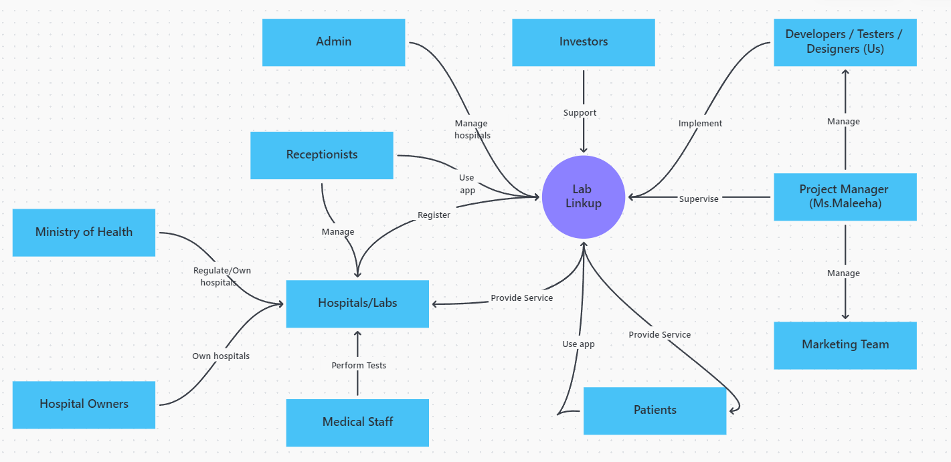

*Picture 1 Stakeholder map*

### Stakeholder Map description

## Interview / Survey Questions

|  |  |
| --- | --- |
| **Question** | **Response** |
|  |  |
|  |  |
|  |  |
|  |  |
|  |  |
|  |  |
|  |  |

## Interview / Survey Summary

# Feature list

|  |  |  |
| --- | --- | --- |
| **Features** | **Main developer** | **Main tester** |
| **Register** | Alya | Maryam |
| **Login** | Alya | Maryam |
| **Add/Edit lab/hospital** | Maryam | Eman |
| **View/delete lab/hospital** | Maryam | Eman |
| **Add/edit package** | Fatema | Hasan |
| **View/delete package** | Fatema | Alya |
| **View labs and tests (search, sort, filter)** | Hasan | Alya |
| **View booking history** | Hasan | Fatema |
| **Book/cancel test** | Eman | Hasan |
| **View/complete/cancel bookings** | Eman | Fatema |
| **Settings** | Alya | Hasan |

# Mockup

## Feature: View labs/tests with search, sort, filter (202101277 – Hasan Mohamed)

## Feature: Booking History (202101277 – Hasan Mohamed)

## Feature: Add/Edit Package (Fatema Mahfoodh – 202100523)

## Feature: view/delete package (Fatema Mahfoodh - 202100523)

## Feature: Register (Alya – 202101399)

## Feature: Login (Alya – 202101399)

## Feature: book/cancel test (Eman Qarooni - 202103421)

## Feature: view/complete/cancel bookings (Eman Qarooni - 202103421)

## Feature: add/edit lab hospital (Maryam Aqeel – 202103328)

## Feature: view/delete lab/hospital (Maryam Aqeel – 202103328)